Project Progress Report

**Overall Mission:** Our project is background subtraction with a freely moving camera. You could check the newest status at github. Website is <https://github.com/guanfangdong/Background_Subtraction_with_a_Freely_Moving_Camera>

**Week 1:**

**Five Tasks:**

(Priority)

1. Find the database and input the database to opencv library. (Done)
2. Calculate the optical flow between two frames. (Done)
3. Visualize the optical flow at a gray image. (Done)

(Optional)

1. Extend the optical flow calculation method to each frame of the video.
2. Visualize the optical flow as playing the video.

**Methods Implement:**

1. draw_flow(img, gray, flow, step):

Reference: https://www.digifie.jp/blog/archives/1448

This function will visualize the optical flow between the two frames. The img and gray are two COLOR_BGR2GRAY images. Flow is the result of optical flow, represented by a (height*width*2) matrix.

2. main():

Main function will handle the dataset input and frames extraction from the videos. It will print the result of optical flow in the end.

**Result:**

Dataset images:

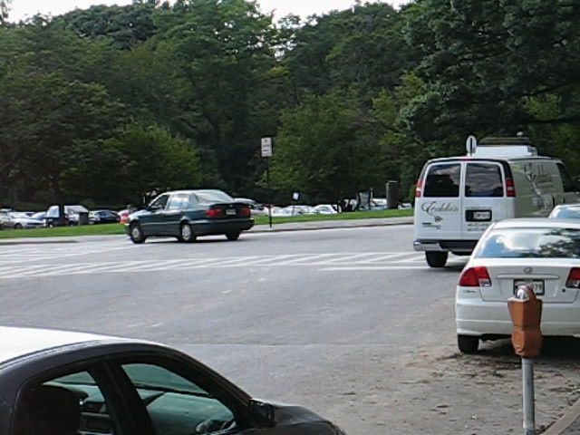

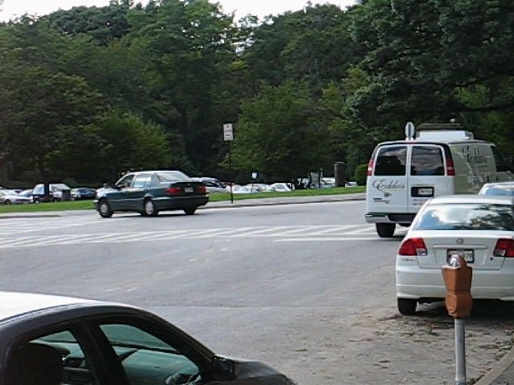

Optical flow image:

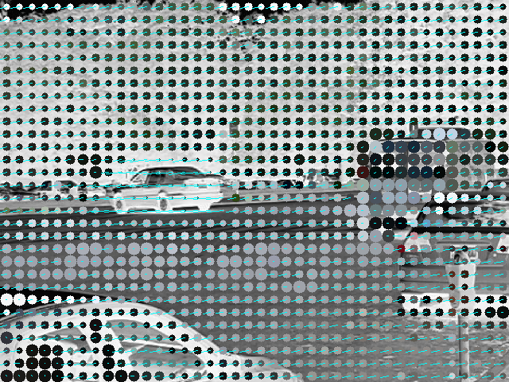

Result of optical flow:

